THE LORD’S SUPPER AT HOLY TRINITY, PITLOCHRY
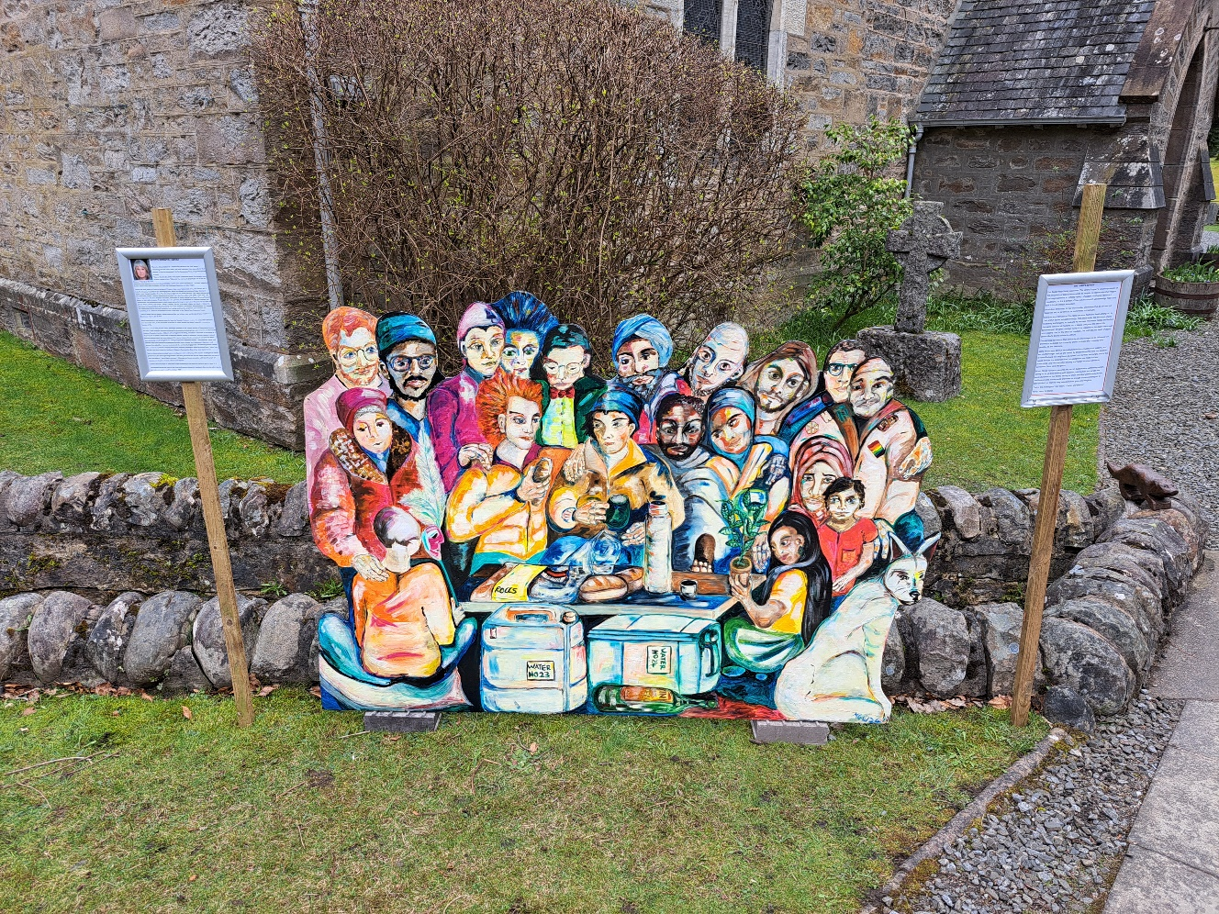
This Easter Holy Trinity welcomes ‘The Lord’s Supper’ a visual expression of the inclusivity of God’s welcome for all people, no matter who they maybe. The image contains an infinite variety of people of all ages, races and conditions, so it is a symbol of how we as a church acknowledge that God’s love is for all without exception. The painting represents that solidarity and encourages us all (whatever we believe) to embrace our humanity and to embrace the humanity of all people. All are Welcome to the unveiling on Monday at 1.00pm followed by Prayers for Peace in the Holy Land in the church.
The painting has been created for us by local artist Myette Godwyn and with the help and support of Pitlochry Festival Theatre represents that solidarity and encourages us all (whatever we believe) to embrace our humanity and to embrace the humanity of all people regardless of religion, sexuality, gender, race, and ability and to embrace the whole of created order.
Myette writes: This is my interpretation of a modern-day version of the ‘Last Supper’ -
welcoming all to the Lord's table, and took inspiration from Leonardo da Vinci’s
painting, in that he interpreted it for his Renaissance times and painted people
he knew. Something very important to me, as a devout Christian, is that Jesus Christ welcomes all - he never judged or turned anyone away when he walked the Earth but challenged hypocrisy and fake religion. I am now a visual artist, theatre maker, playwright (member of the Scottish Society of Playwrights), director,
and actor. Both my drama school principal tutors were Quakers and I used to stay at the Quaker meeting house when I performed at the Edinburgh Fringe Festival. One thing that struck me and has always stayed with me since is their core value of ‘that of God in everyone". All people can have a connection with God. All people are
valuable and should be treated with love and respect.’

It has been a pleasure to work with Myette and The Festival Theatre to create, this image of love, diversity and inclusivity.
The Painting is on display in the Churchyard until 4th April and can be available for anyone in the Diocese to display and use at any time.

