Serenity Garden
“A sacred space of peace and inspiration”
All are welcome to enjoy the peace and seclusion of the Serenity Garden at Holy Trinity Episcopal Church, Perth Road, Pitlochry. A beautiful, quiet, sheltered space to meet friends for those outdoor, lockdown get togethers, or just to have some time to yourself away from the busy-ness of home; the garden can be accessed through the churchyard at any time.
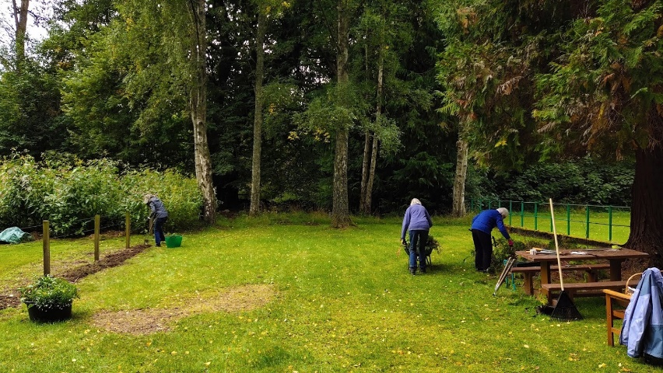
We intend to establish the Serenity Project – a voluntary group for people who will create and maintain the garden as part of their journey towards healing and wholeness through community with each other and connection to nature. Lockdown inhibits our ability to gather people for this at the moment but we shall move forward with it as restrictions allow.
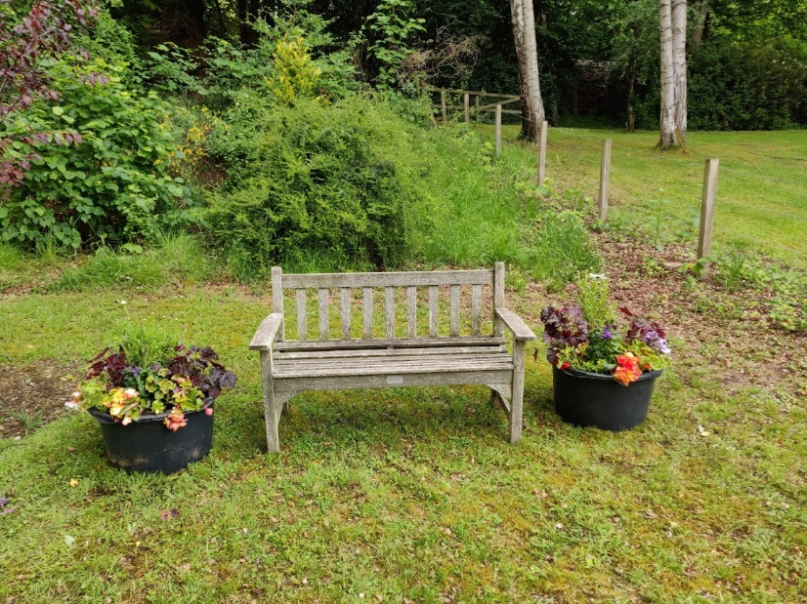
In the meantime, we meet in pairs to work on aspects of the garden, usually on a Thursday. Please contact Rachael (Ordinand-in-Training) for more information at rwright.hplc@gmail.com .

