THE SCOTTISH EPISCOPAL CHURCH
Highland Perthshire Linked Charge
Invites you join us
Christmas
2021

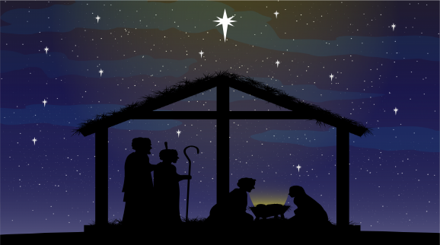

Holy Trinity Church, Perth Road, Pitlochry -Contact – Robin Baker - 01796 472005
Sunday Services at 9.30am (No service on 26th December)
Sunday 28th November - 3.30pm Advent Carol Service, All welcome.
17th to 24th 10.30am, 8.00am on 19th Dec– Morning Prayer/Advent Antiphons(on Zoom)
24th December – 4.00pm ‘ Christingle ‘In the Garden‘ (for all the family, bring a torch or lantern)
24th December – 8.00pm ‘Christmas Communion’ All welcome
25th December – 9.30am All Age Christmas Communion (bring your presents)

Kilmaveonaig (St Adamnan’s Church), opposite former Tilt Hotel, Blair Atholl.
Contact - Mrs. Lavinia Gordon 01796 481230.
Sunday Services at 11.15am (No service on 26th December)
19th December – 3.30pm Carols by Candlelight
25th December – 11.15am All Age Christmas Communion (bring your gifts)

St Andrew's, Church, Strathtay, opposite the local shop.
Contact - Ms. Lesley Whitwood 01887 840416
Sunday Services at 11.15am (No service on 26th December)
19th December – 3.30pm A service of 9 Lessons and carols
24th December – 5.00pm A Christingle Service for the whole family
24th December – 11.30pm Midnight Mass
25th December – 10.30am Christmas Communion (by Extension)
House Group – Last Wednesday of the month contact Ms. Lesley Whitwood 01887 840416 for details

All Saints, Kinloch Rannoch Square in the village Square. The church is open daily in daylight hours. Contact – Reverend Canon Liz Baker 01796 472005:
Services at 9.30am on 1st Sunday of the Month
26th December – 11.00 A Celebration of Christmas (with Church of Scotland at the Old Church)
28th December – 3.00pm Carol Service (At Braes of Rannoch – booking essential)
2nd January – 9. 30pm Christmas Communion (At All Saints)

“Let us now go even unto Bethlehem,
and see this thing which is come to pass,
which the Lord hath made known unto us” Luke 2:15

